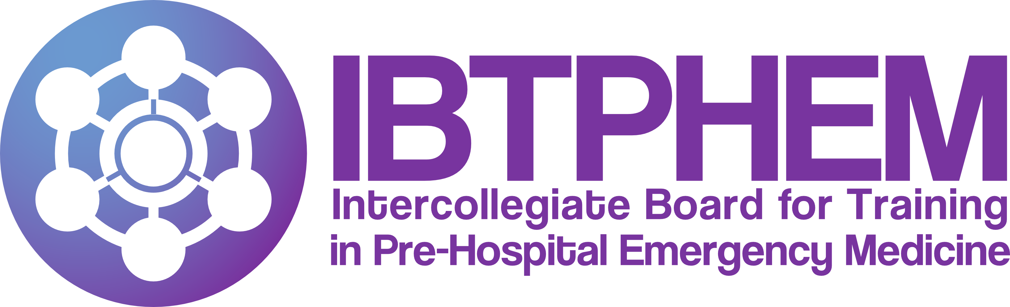
c/o The Royal College of Surgeons of Edinburgh
Nicolson Street, Edinburgh EH8 9DW
T +44 (0) 131 527 1732
Email: ibtphem@rcsed.ac.uk
Website: www.ibtphem.org.uk

Application for IBTPHEM Training Committee – Sub-committee

1. Personal Details
Title Last name First name(s)

Telephone number Email address

Training Programme Area Role In PHEM Training

2. Please indicate which sub-committee you are interested in joining

Recruitment National Training Quality Educators

3. Statement of Interest – please indicate why you would like to join the sub-committee and what you will bring to the role?

4. Declaration of accuracy and data sharing

I agree to the following statement:

- I agree that the information provided by me may be processed, in accordance with the Data Protection Act, for legitimate purposes connected with my application.

Signature of applicant and date
Signature:
Date:

