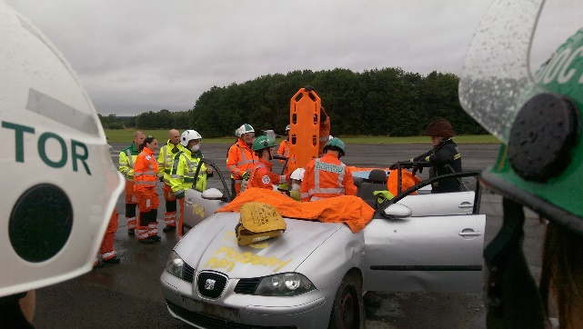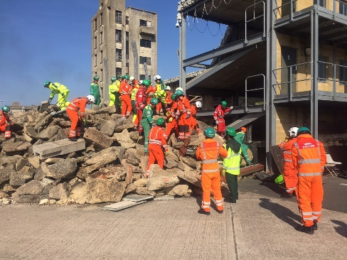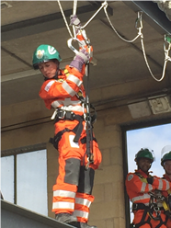

2019 Pre-Hospital Emergency Medicine Induction Course
Saturday 10th – Friday 16th August 2019 Inclusive

Lincolnshire Fire and Rescue Service

Waddington Training Facility, Bracebridge Heath, Lincoln

The IBTPHEM National Prehospital Emergency Medicine Induction Course is an annual seven-day residential course designed specifically for those commencing careers in Prehospital Emergency Medicine (PHEM).
The course focuses on:
- Personal, team and patient safety
- Human factors and Team Resource Management
- Principles of pre-hospital emergency medical care
- Developing and maintaining psychosocial resilience
- The PHEM sub-specialty curriculum

The course is delivered by a multi-professional faculty of experienced PHEM practitioners supported by administrators and guest speakers. The course is residential and all-inclusive with accommodation and meals provided at the DoubleTree by Hilton Hotel, Lincoln. The course provides:
- A supportive learning environment and culture
- Over 10 hours of interactive case-based discussions
- Over 30 hours of scenario based teaching
- Part-task and full-immersion simulator based training in different PHEM environments
- Medical and Surgical Skills workshops
- Major incident training
- Work-place based assessments for PHEM sub-specialty trainees

Cost: £2000 per person
The course is open to people working in, or interested in a career in PHEM who are:
- Fully registered doctors of ST4 or above (including Consultants, SAS Doctors and GPs)
- Critical care or trainee critical care paramedics
- Nurses working in acute specialties who have been fully registered for at least 4 years
You will require the following PPE: fluorescent jacket (or ‘flight suit’), gloves, helmet and boots.
To apply please complete the form below and email to ibtphem@rcsed.ac.uk. Please note that you will not be permitted to undertake the course you do not have insufficient post-registration clinical experience.

Registration Form for Pre-Hospital Emergency Medicine Introductory Course: Individual

Please note that payment is required PRIOR to the commencement of the course, and an invoice will be sent on acceptance of a place. Invoices will be sent from the Royal College of Surgeons of Edinburgh.
If you have any questions please feel free to contact us at ibtphem@rcsed.ac.uk

Name

If you are part of a pre-hospital scheme (e.g. air ambulance, BASICS) please write the name here

Email address

Postal address for invoice

Profession, Grade and Years post full registration

Doctors: do you have at least 1 years’ experience in anaesthesia/intensive care and intend to practice pre-hospital emergency anaesthesia? (Please note that answering ‘no’ does not prevent you from attending!) | Yes / No / Not applicable
I confirm that I will be able to bring the appropriate PPE. I understand that failure to do so means that I will not be able to participate in the practical elements of the course | Yes / No/I will need to borrow: (please list items)

An invoice and full programme will be sent on receipt of this form and acceptance on the course.

Registration Form for Pre-Hospital Emergency Medicine Introductory Course: Organisational

Please note that payment is required PRIOR to the commencement of the course, and an invoice will be sent on acceptance of a place. Invoices will be sent from the Royal College of Surgeons of Edinburgh.
By entering candidates you are confirming that they have adequate experience to undertake the course.
If you have any questions please feel free to contact us at ibtphem@rcsed.ac.uk

Name of organisation

Name & Email address of Contact

Postal address for invoice

Trainee Names | Email Addresses | Grade & Specialty

An invoice and full programme will be sent on receipt of this form and acceptance on the course.

