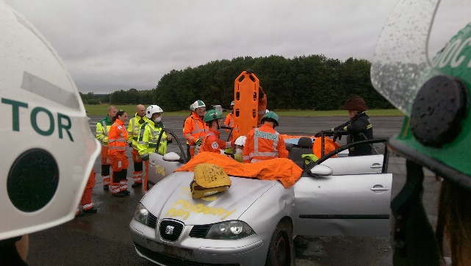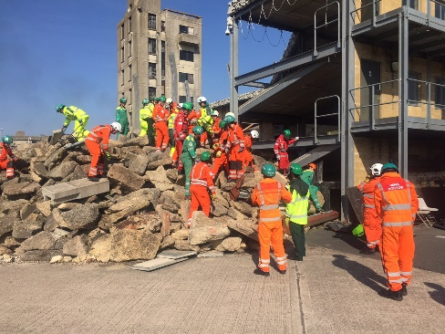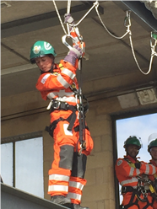

Pre-Hospital Emergency Medicine Introductory Course
Saturday 4th – Friday 10th August 2018 Inclusive

The Fire Service Training College

London Road, Moreton in Marsh, Gloucestershire GL56 0RH

Course Content:
- Themed Case-based workshops
- Introduction to pre-hospital emergency services and environment
- Introduction to CRM and Error Theory
- Medical and Surgical Skills workshops (including surgical airways, thoracostomy, thoracotomy and Emergency Caesarean Delivery)
- Using pre-hospital equipment
- Scene safety, hazards, dynamic risk assessments and entrapment
- Extrication
- PHEM in different environments
- Major Incidents - being first on scene or in an operational role
- Knowledge Review
- Trainees meeting for PHEM trainees

48 hours of training, including theory and practical workshops, 18 simulations and 2 major incident exercises. Course certificate and workplace-based assessments
Fully Resident
Price: £2000 per person
Open to people working in, or interested in a career in PHEM who are:
- Fully registered doctors of ST4 or above (including Consultants, SAS Doctors and GPs)
- Critical care or trainee critical care paramedics
- Nurses working in acute specialties and been fully registered for at least 4 years
You will require the following PPE: fluorescent jacket (or ‘flight suit’) and boots.
To apply please complete the form below and email to ibtphem@rcsed.ac.uk and mariasmith@doctors.org.uk. Please note that you will not be permitted to undertake the course if we believe that you have insufficient post-registration experience

Registration Form for Pre-Hospital Emergency Medicine Introductory Course: Individual

Please note that payment is required PRIOR to the commencement of the course, and an invoice will be sent on acceptance of a place. Invoices will be sent from the Royal College of Surgeons of Edinburgh.
If you have any questions please feel free to contact us at ibtphem@rcsed.ac.uk

Name

If you are part of a pre-hospital scheme (e.g. air ambulance, BASICS) please write the name here

Email address

Postal address for invoice

Profession, Grade and Years post full registration

Doctors: do you have at least 1 years’ experience in anaesthesia/intensive care and intend to practice pre-hospital emergency anaesthesia? (Please note that answering ‘no’ does not prevent you from attending!) | Yes / No / Not applicable
I confirm that I will be able to bring the appropriate PPE. I understand that failure to do so means that I will not be able to participate in the practical elements of the course | Yes / No/I will need to borrow: (please list items)

An invoice and full programme will be sent to you on receipt of this form and acceptance on the course.

Registration Form for Pre-Hospital Emergency Medicine Introductory Course: Organisational

Please note that payment is required PRIOR to the commencement of the course, and an invoice will be sent on acceptance of a place. Invoices will be sent from the Royal College of Surgeons of Edinburgh.
By entering candidates you are confirming that they have adequate experience to undertake the course.
If you have any questions please feel free to contact us at ibtphem@rcsed.ac.uk

Name of organisation

Name & Email address of Contact

Postal address for invoice

Trainee Names | Email Addresses | Grade & Specialty

An invoice and full programme will be sent to your trainees on receipt of this form and acceptance on the course.

